Insight reports have been configured to enable reporting on surveys created for the onboarding checklist.
Contents

A. Creating a new report 1
1. Standalone report 1
2. Adding a hard-coded filter 3
3. Adding an optional filter (Parameter) 4
4. Adding a sort order 6
5. Creating calculations 7
6. Creating a multi tabbed report 8
7. Sharing a report 10
B. Editing reports 12
1. Tabs 14
2.1. Rename a tab 14
2.2. Re-order the tabs 15
2. Filters and Sorts 16
3. Calculations 17

Knowledge Article: Insight reports

Creating a new report

Navigate to: CorePortal > Insight

Standalone report

- Click on ACTIONS - Create Report.

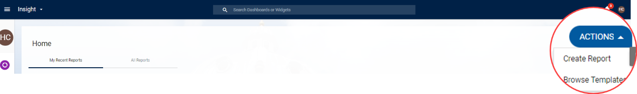

- Choose Table or Pivot and enter the name of the new report

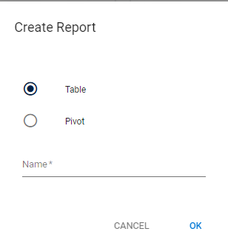

- Click on ADD and choose Column

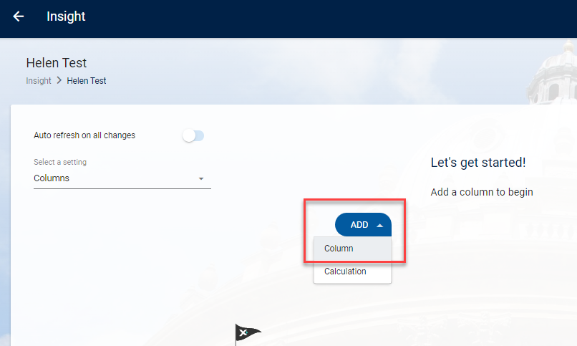

- Enter details in the left field to search for a data field e.g. Person reference

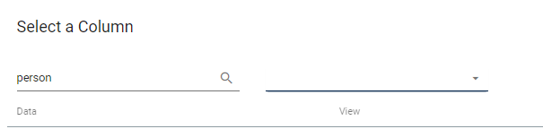

- Enter details in the right field to search for a table or view

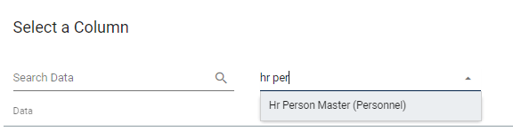

- Enter search criteria in both fields to search for a column within a specific table/view

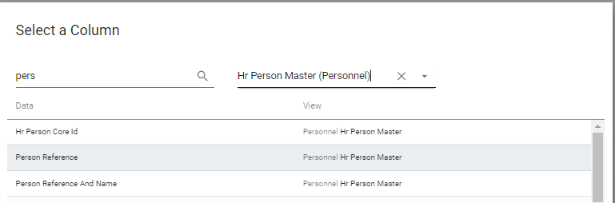

- Click on the item to insert it into the report

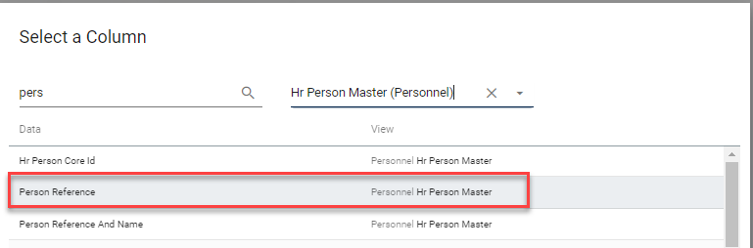

- Repeat the steps above for each item to be added into the report then click OK to close the window

 | NB: When adding details from a survey you must include at least one field from HR Person Master as this is the only view that surveys are joined to.

Adding a hard-coded filter

- Under Select a setting choose Filters and click ADD

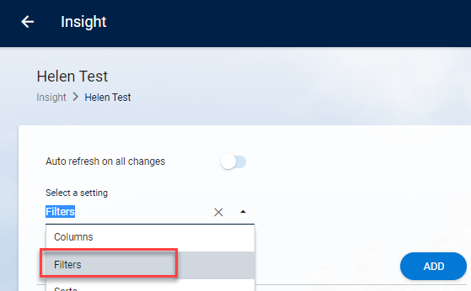

- Select the Report Column (1) you wish to filter on and the Operator (2)

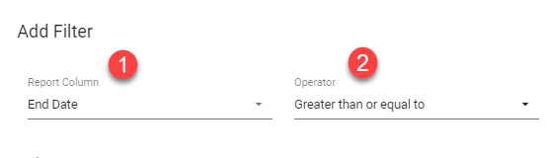

- Depending on which operator you choose you may need to enter Filter Text or Filter Date if applicable

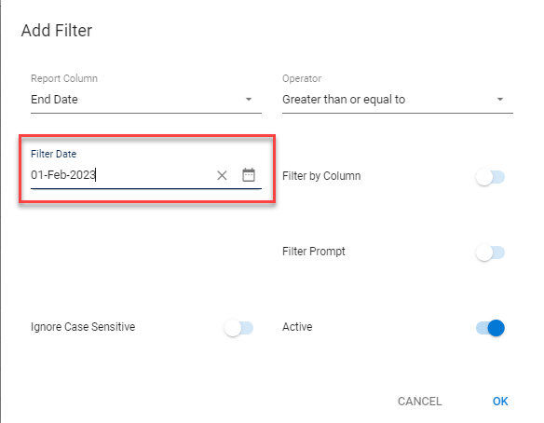

- Click OK to save the filter

- Filters added appear on the left of the page

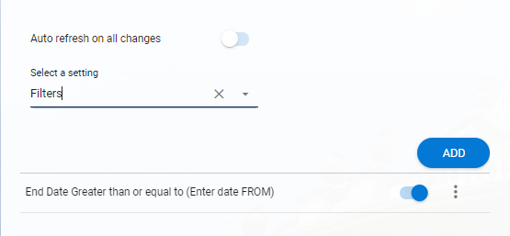

Adding an optional filter (Parameter)

This will enable the end user to enter criteria to restrict the report results

- Under Select a setting choose Filters and click ADD



- Select the Report Column (1) you wish to filter on and the Operator (2)



- Toggle Filter prompt ON (3) and enter Prompt Text (4)

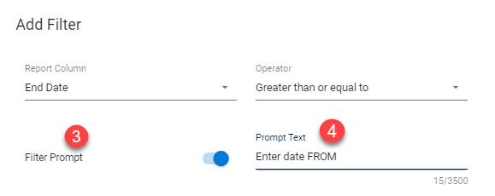

 | NB: Prompt text will be displayed to the user.

- Click OK to save the filter

- Click REFRESH to view the Prompt

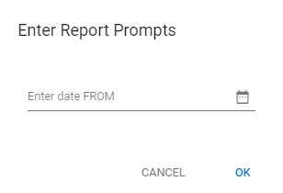

- Filters appear on the left of the page



Adding a sort order

- Under Select a setting choose Sorts and click ADD

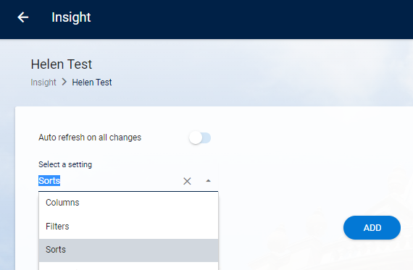

- Choose the Report Column and the Sort Direction

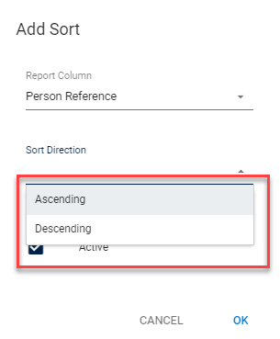

- Click OK

- Sorts added appear on the left of the page

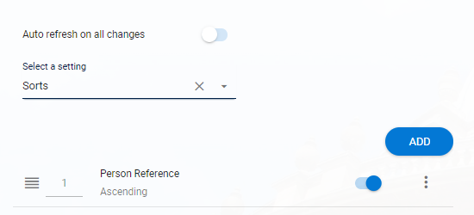

Creating calculations

- Ensure that Columns are selected under Select a setting

- Click on ADD and choose Calculation

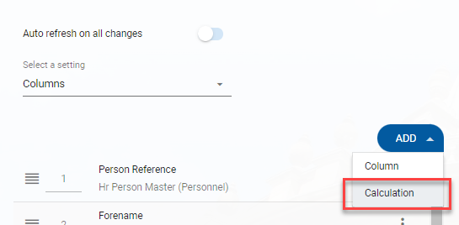
- Enter a name for the calculation, then create your calculation in the Calculation Text field.

 | NB: How to create specific calculations is not covered in this guide

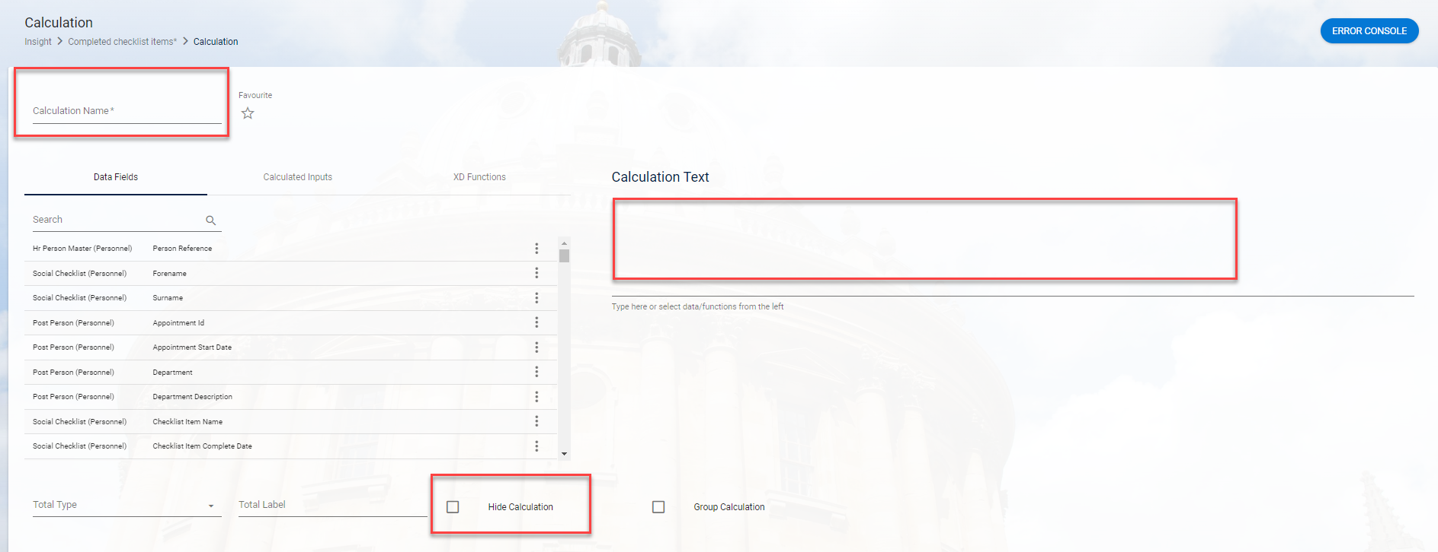

- If you do not want the calculation to appear as a column in the final report, click on Hide Calculation.

Creating a multi tabbed report

Navigate to: CorePortal > Insight

- Follow the steps in Section 1 to create the first tab.

 | NB: The name you give the first tab will become the name of the overall report. Instructions on how to edit the TAB and report names are in Section B step 2.1

- Under Select a setting choose Tabs

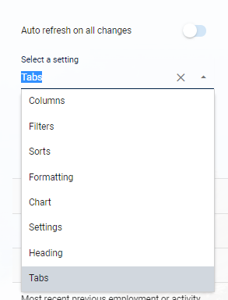

 | NB: The first tab you created will be displayed

- Click on ADD and choose Add New Tab

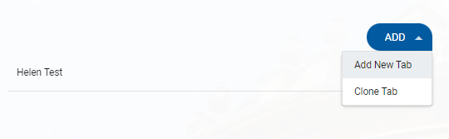

- Enter the name for the new tab and click OK

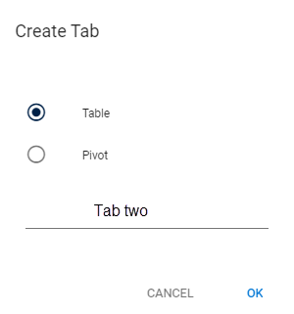

The second tab is now displayed at the top of your report

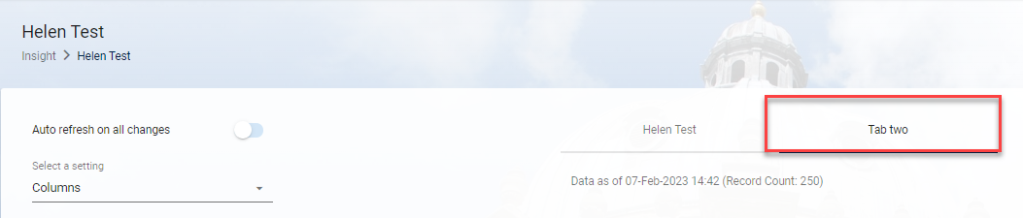

 | NB: A list of tabs is also displayed under Select a setting > Tabs

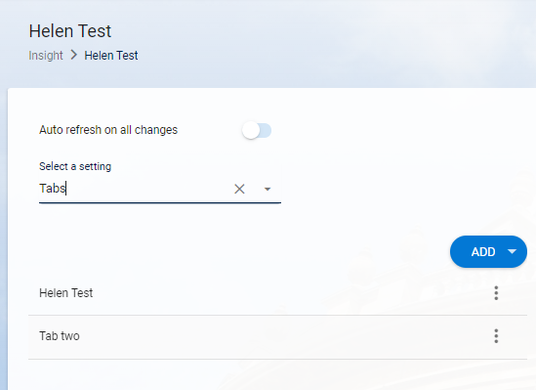

- Continue to configure the new tab following the steps in section 2, 3 and 4 as applicable.

Sharing a report

- Open the report, click on ACTIONS and choose Share/Schedule

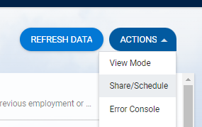

- The screen defaults to Share > Share with employee

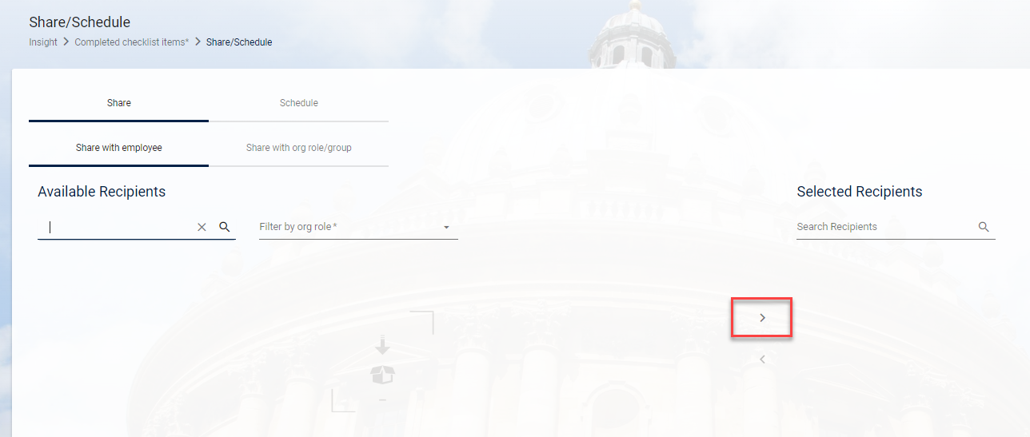

- Search for the first recipient in Available Recipients

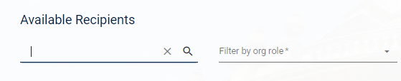

- Tick the box and click on the arrow to move the individual to Selected Recipients

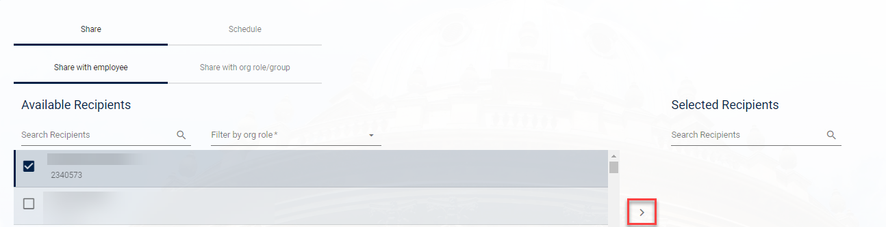

Individuals that the report has been shared with can be viewed under Selected Recipients

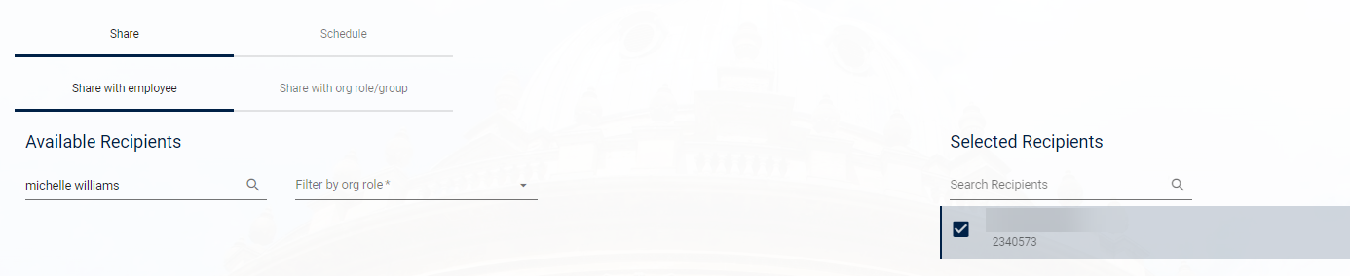

Editing reports

Navigate to: CorePortal > Insight

There are two ways to access existing reports – My Recent Reports and All Reports

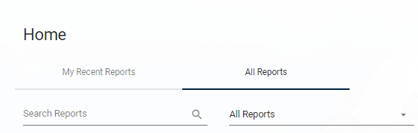

In My Recent Reports the reports appear as tiles.

- Click on the relevant tile to open a report.

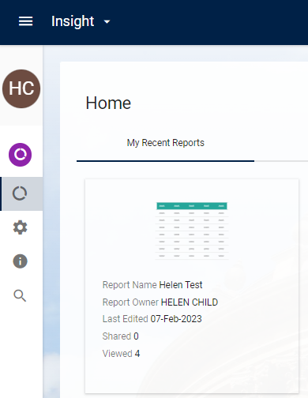

- To edit the report, go to ACTIONS and choose Edit Mode

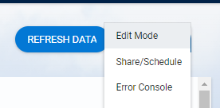

 | NB: For tabbed reports click on the relevant TAB first

In All Reports the reports are displayed in a list, with a sub heading for standalone reports.

- Click on the arrows to expand or collapse the list.

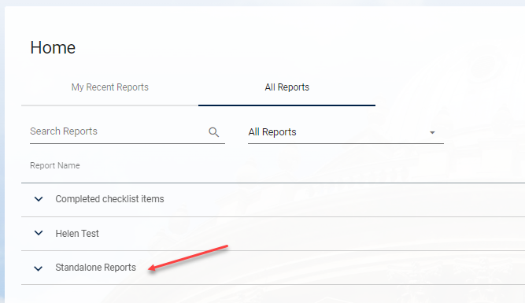

- Click on the ellipses against the report or tab and choose Manage

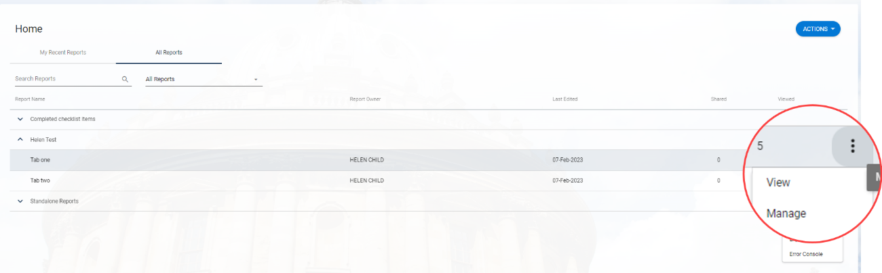

- To edit the report, go to ACTIONS > Edit Mode



Tabs

Navigate to: CorePortal > Insight

- Open the report and click on a tab

- Under Select a setting choose Tabs

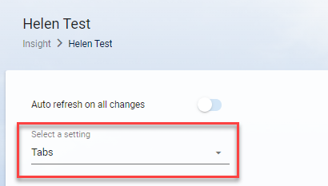

Rename a tab

- Click on the ellipses against the tab to be edited and choose Edit

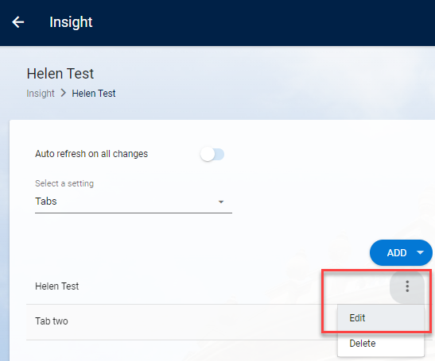

- Enter a new Tab Name and click OK

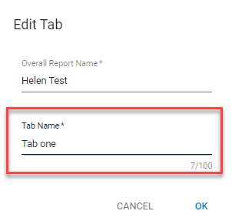

- The new tab name is now displayed

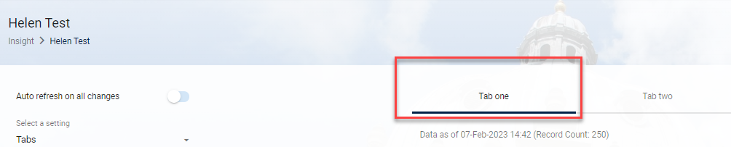

 | NB: On the first tab you also have the option to rename the report

- Enter the new name under Overall report Name

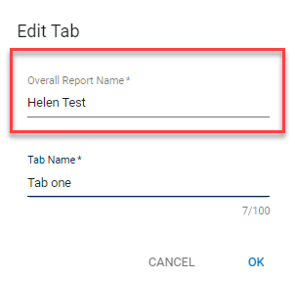

- Click OK to save the change

Re-order the tabs

 | NB: You cannot change the position of the first tab.

- Click on the ellipses against the tab to be edited and choose Edit


- Overtype the number or use the arrows to move the number up or down and click OK

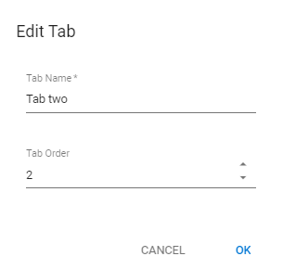

Filters and Sorts

- Under Select a setting choose Filters or Sorts as applicable

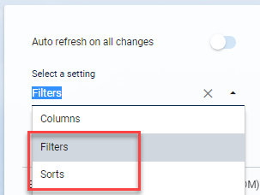

- Click on the ellipses and choose Edit

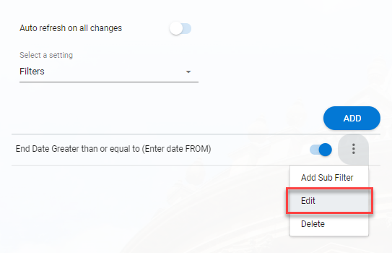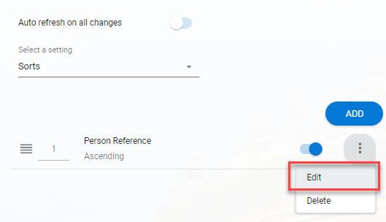

- Make the required changes and click OK

Calculations

 | NB: Existing calculations are displayed in the Columns list.

- Under Select a setting ensure Columns is displayed (default)

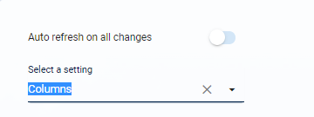

- Locate the calculation in the list, click on the ellipses and choose Edit

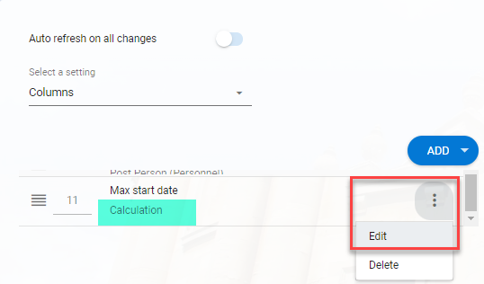

- Make the changes as required and SAVE

